Teacher/Mrs.Messaoud Jalila Guidelines for writing level 4th Forms/2017
I /Types of compositions
When you a composition you need to know the type of writing required . your piece of writing can be in the form of a letter, an article for a magazine or a newspaper or it can be a report.
LETTERS are written to a person( a pen friend,a newspaper editor , a travel agent , a manager, a headmaster etc…)or a group of people (a local football team, festival organizers etc…)for a specific purpose( to give advice , to make a complaint , to enquire about sthg …)
Informal letters :written to people you know in personal chatty style.
Formal letters : to managers/ officials written in a polite and formal style.
ARTICLES are found in in magazines and newspapers.they can be found inthe following types :
- Descriptive : describing people,places,buildings,objects , festivals ceremonies etc…
- Narrative : about real or imaginary events which happened in the past. They can be written in the first person (first-person narratives) when the writer is the main character in the story or in the third person (third-person narratives)when the writer is describing events which happened to another person or group of people.
- News reports : about current events ( murders , fires earthquakes…)written in impersonal style(generally using passives).facts re presented objectivelly and unemotionally.
- Reviews : discussing a film, TVprogramme,book,restaurant… and recommending it or not to the reader.
- For and against essays : presenting pros and cons on a specfic topic.
- Providing sollutions to problems : which discuss a problem and its causes, making suggestions and mentioning the expected results and consequences.
- Letters to editors : which presents the writer’s personal opinion on a specific topic or the writer’s suggestions on a specific problem.
- Reports :discussing the suitability of a person ,place, plan ,… for a particular purpose or job…
Or discussing suggestions or decisions about future actions.

II /Understanding the rubrics (composition instructions)
Read the rubric carefully and underline the the key words/phrases which will help
Your decisions about the genre ,the type, the techniques and the plan of your composition depend on your understanding of the rubric which will help you decide what you will write about. Key words /phrases inindicate :
- The imaginary situation you will write about( e.g. you’re a reporter you will write a report about a new film, an exhibition, a play a festival . This will always suggest who you are.
- The imaginary reader who is gong to read your piece of writing( e.g. the manager of the company you work for has asked you to write an e mail to enquire about price(s) of a product.. This will help you decide on the writing style i.e.the appropriate style -formal/ informal- you will use.
- The the type of writing(a letter/an article/describing an event )
- The specific topics you should write about(e.g. giving a speech about the hazads of smoking ways and benefits of quitting it).
Study the example below :
You work for a travel magazine¹ . your editor² has asked you to write an article³ discussing the ⁴pros and cons of air travel including factors such as cost and convenience⁴.
1-situation 2- reader 3- type of writing 4- specific topics
III/ Brainstorming
- Write down any idea , words and phrases that you can think of,
which relatete to the specific topics of your composition.
- Group your ideas ,crossing out any irrelevant ones , and put them into logical order.
- Check that your ideas are relevant to the topics in the rubric.
IV/ Planning the lay out.
Your ideas should be organised into paragraphs. The layout of most types of writing consists three parts : an introduction , a main body and a conclusion.
- Introduction : it’s the first paragraph whose purpose is to give the reader a general idea of the subject of the composition . It should attract the reader so that s/he wants to continue reading .
- Main body : it usually consists of two or more paragraphs and its purpose is to develop points related to the subject of the composition . the number of paragraphs and the way you devide them depend on the specific topics. Each paragraph should deal with points related to the same topic. Whenever you discuss a new topic , you should begin a new paragraph. e.g. in a for and against essay the main body should have two paragraphs.
Main body paragraphs should begin with topic sentences. A topic sentence introduces or summarises
the main topic of the paragraph and gives the reader an idea of what the paragraph will be about.
The topic sentence should be followed by supporting sentences which provide examples , reasons ,
Justifications and/or evidence to support the topic sentence.
- Conclusion : the conclusion is a short final paragraph in which you summarise the main idea of the subject, restate your opinion in different words , make general comments , express your feelings,etc…
More detailed information about the parts of an essay.
Essays, like sandwiches or burgers, are divided into different parts. These parts are : 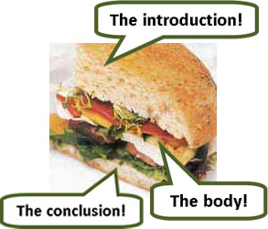

The Introduction The introduction opens the essay. It is a short paragraph – usually about THREE sentences. In an argument essay, it usually describes or summarizes both sides of the present situation and says what you are going to do in your essay.

The Body The Body is the main part of the essay. In an argument essay, it is divided into two or three paragraphs, giving your opinion and reasons. Each paragraph in the body is between FIVE and SEVEN sentences long.

Conclusion The Conclusion is the end of the essay. It is a short paragraph – about THREE sentences. It often has the same idea as the Introduction, only in different words. Some people think of the essay as a sandwich. The Introduction and Conclusion are the bread, and the Body is the filling in the center. If the introduction looks good, people will carry on to the body. Hopefully, the conclusion will leave them with a nice taste in their mouth…
- The Introduction
One easy way to write the introduction for an argument or opinion essay is to write THREE sentences:
- two about the topic
- one thesis sentence
You can write either Situation or Opinion introductions. There’s not much difference between them.
- Situation Introductions
- Opinion Introductions

- Situation Introductions

Write two sentences to describe the two sides of the present situation. The third sentence – the Thesis sentence – will describe what you are going to do in your essay.
- Sentence 1: One side of the present situation.
- Sentence 2: The other side of the present situation.
- Sentence 3: Thesis: What you are going to do in your essay.

Examples :

Who should take care of our old people?
Sentence 1 | In my country, most old people live happily with their children
Sentence 2 | Increasingly, however, many families cannot take care of their parents
Sentence 3 (Thesis) | This essay will describe some of the problems involved with taking care of old people, and discuss who should be responsible.

Does Aid to Poor Countries Work?
Sentence 1 | For the last fifty years, poor countries have been receiving huge sums of money from rich donor countries.
Sentence 2 | Some of this money has improved lives, while much of it has disappeared or made no difference.
Sentence 3 (Thesis) | In this essay, I will discuss some arguments for and against foreign aid.

Should dangerous sports be banned?
Sentence 1 | Every year, thousands of people are injured or killed in sports such as boxing or motor-racing.
Sentence 2 | Because of this, many people are opposed to such sports, and want them to be stopped or controlled.
Sentence 3 (Thesis) | This essay will look at some of the arguments for and against banning dangerous sports.
- Opinion Introductions
In this kind you give two opposite opinions in the first two sentences. The third sentence says what you are going to do.

Does space exploration benefit mankind? (1)
Sentence For | Many people are excited about space exploration.
Sentence Against | However, others feel it is a massive waste of money
Sentence 3 (Thesis) | This essay will look at some of the arguments for and against space exploration.

Does space exploration benefit mankind? (2)
Sentence For | Space, for many people, really is the final frontier. They are excited by the exploration and potential of space.
Sentence Against | However, not everyone agrees that this money is well-spent. Many people feel that we should solve problems here on earth before beginning our journey to space
Sentence 3 (Thesis) | This essay will look at some of the arguments for and against space exploration.

Do Athletes Deserve Their High Salaries?
Sentence 1 | Everyday, we read about new record contracts and salaries earned by sportsmen and women. Some people do not agree with these huge payments
Sentence 2 | Others believe that our sports heroes deserve every penny.
Sentence 3 (Thesis) | This essay will look at some of the arguments for and against the high salaries of athletes.
As well as situation or opinion introductions, you can use the following variations:
- Past and Present: One sentence about the situation in the past, one about the situation today.
- Here and Elsewhere: One sentence about the situation in one place, one sentence about the situation or problem in another place.
- You and Other People: One sentence about what most people do or think, one sentence about what you believe, or do, or feel.
Finally, if you are having problem thinking about an introduction, leave some space (enough for three or four sentences) and write or type it later – AFTER you write the body or conclusion.
- The Body:
What makes a body look good? Paragraphs, that’s the answer! If your paragraph is in good shape, your body will look good and feel good.
Here’s what you need to have in a body paragraph.
- Topic Sentence
- Argument or Reason 1
- Example, Explanation, or supporting detail
- Argument or Reason 2
- Example, Explanation, or supporting detail
- Argument or Reason 3 (Three is a magic number. Always aim to have 3 ideas.)
- Example, Explanation, or supporting detail
- Paragraph summary (optional)
Example
- Is Education Being Devalued?
Topic Sentence | People have several arguments against the need for degrees.
Argument or Reason 1 | They say that having so many graduates devalues a degree.
Example, Explanation, or supporting detail | People lose respect for the degree holder.
Argument or Reason 2 | It is also claimed that education has become a rat race,…
Example, Explanation, or supporting detail | …since graduates have to compete for jobs even after years of studying.
Argument or Reason 3 | Another point is that studying for such a long time leads to learners becoming inflexible.
Example, Explanation, or supporting detail | By that I mean that they know a lot about one narrow subject, but are unable to apply their skills.
Even more supporting details… | Employers, on the other hand, prefer more flexible and adaptable workers.
- People have several arguments against the need for degrees. They say that having so many graduates devalues a degree. People lose respect for the degree holder. It is also claimed that education has become a rat race, since graduates have to compete for jobs even after years of studying. Another point is that studying for such a long time leads to learners becoming inflexible. By that I mean that they know a lot about one narrow subject, but are unable to apply their skills. Employers, on the other hand, prefer more flexible and adaptable workers.
- The Conclusion
The conclusion is the end of the essay. It is the last part of the essay and it is the part that the reader may remember most. It should be clear and avoid confusing the reader.
The reader expects the conclusion to do some or all of the following
- rephrase the question
- summarize the main ideas
- give your opinion, if you haven’t given it already
- look to the future (say what will happen if the situation continues or changes)
The reader DOES NOT expect new information in the conclusion. Never add a new idea just because you have thought of it at the end!
You must do all of this in just three or four sentences!

Vocabulary is Important
The conclusion is very similar to the introduction. However, you should avoid repeating the same words. This is why a few minutes spent at the start of the exam writing down synonyms (words with the same meaning) and related words is very helpful.
After all, if you only have a 250-word essay but use the same word 10 times, this will not show the examiner what you know.

Wrapping Paper
Another way to look at the Introduction and the Conclusion is to think about gift wrapping paper. Your intro and conclusion wrap around your essay like a piece of bright paper “wraps” a present. They are not the main part of the essay, but they do make your essay look good.
Your conclusion ‘wraps’ up the essay. We don’t put something valuable, like money or gold, hidden in the wrapping paper, so don’t put new information or important ideas in the conclusion.

Rubric samples
Writing tasks/bac 2010-2016
4-mark guided writing task | 8-mark free writing task
Biography | Country life VS city life | 2010
Virtual schools/benefits & side effects | Life concerns/ environment/ energy overconsumption : practical solutions to save it | 2011
Completing a conversation/wh&yes/no question formation | City life VS country life | 2011
Ipad presentation/ item description | Brain gain VS brain drain | 2012
Using data on a pie chart about health risks of smoking | Effects of addiction to new and screen –based techs. | 2012
WHO.organization | Thanking letter to a tour operator | 2013
Dehydrated sentences on saving energy/ecodriving | Justified or unjustified worries of a mother about her teenage son’s addiction to social networking | 2013
Green peace organization | Article on the filthy habit of smoking and tips how to quit it | 2014
Earth day manifestation | Life long learning /advice letter(response) | 2015
Life concerns /5 portions a day | Brain drain VS brain gain | 2015
Using data on a bar chart about virtual school enrollment | The choice to opt out
4-mark writing samples
Writing a biography
Birth : was born
Achievements
awards
Death : died at the age of (date of birth - date of death/ 1937-1881= 54 years)
Pronoun : third person singular.
Tense : simple past
Pablo picasso was born in1881. Picasso demonstrated extraordinary artistic genuis in his early age. e he created a large scale of paitings, drawings and sculptures. His portrait , Guemica , created in 1937 was one of influential piece of the time. Picasso died in his late fifties.
Writing a definition : The virtual school is a modern approach of learning. It’s a comfortable and a good option for handicapped people who are able to avoid the daily challenge of moving to school to attend courses. It’s also convenient for bullied students who suffer physically and morally at school. However it’s not disadvantage free since virtual students have limited social life and are so inactive that they can suffer from lack -of -execise- related diseases.
Describing an item/product : The iPad is a new kind of computers . It’s flat and thin about 1.25centimeters.it’s also light . Unlike computers , it doesn’t have a keyboard or a mouse it functions by a mere screen touch. The iPad cost ranges between $499 and $829. It has the same options of any new screen –based technology, infact the user can need it to send emails and take photos . it’ s also used for intertainment, to listen to the letest hits or watch brand new movies. It’s also convenient for work . It’s not only a word processor but also a virtual library that can help students with appropriate resourses.
Percentage | Fraction
80% | four-fifths
75% | three-quarters
70% | seven in ten
65% | two-thirds
60% | three-fifths
55% | more than half
50% | half
45% | more than two fifths
40% | two-fifths
35% | more than a third
30% | less than a third
25% | a quarter
20% | a fifth
15% | less than a fifth
10% | one in ten
5% | one in twenty
Other 4-mark writing tasks.
- writing about graphs.
- Writing about pie charts.
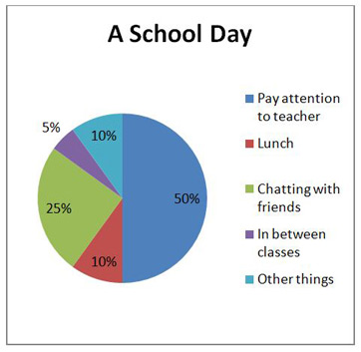
If the percentages are not exact as above, then you can use qualifiers to make sure your description remains accurate. Here are some examples:
Percentage | Qualifier
77% | just over three quarters
77% | approximately three quarters
49% | just under a half
49% | nearly a half
32% | almost a third
This table presents some examples of how you can change percentages to other phrases

Percentage | proportion / number / amount / majority / minority
75% - 85% | a very large majority
65% - 75% | a significant proportion
10% - 15% | a minority
5% | a very small number
- Writing about graphs , tables and diagrams.
Often , data presented in a graph or a table show change over time. There are specific verbs , adjectives and adverbs that can help you describe these changes . For example :
Verbs for describing how data have changed
- To increase # to decrease
- To go up # to go down
- To rise # to decline
- To climb # to drop
Words or expressions that can be used when there’s no changes :
- Remain/be steady
- were unchanged
- did not change
- remained constant
- remained stable / stabilized
. Adjectives and adverbs to describe how fast the change occured :
- Sharp(ly)
- Dramatic(ally)
- Significant(ly)
When the change is not sharp or significant it can be described using steady, gradual or slight .
What introductory expressions to use ?
There are 3 possible ways to start.
- The first to refer to the visual directly(e.g.this graph shows the population of Asia in the 20th C.)
be careful of recopying the examiner’s sentences.
- The second way is to refer directly to the main message conveyed by the visual (e.g.there was a sharp increase in the population of Asia in the 20th C. )
Introductory expressions :
- (As )the graph /table shows/indicates /illustrates/reveals/represents
- It’s clear from the graph/table
- It can be seen from the graph/table ---As can be seen from the graph/table
- As is shown /illustrated by the graph /table
- From the graph /table it is clear
NB. As you can notice it is best to avoid using personal pronouns . Instead of saying we can see from the graph … it’s better to use the passive or impersonal construction as previously shown in the above expressions which most of them can be followed by a clause starting with that .
Time expressions : The most common ones :between….and…/during…/in…./before…/after…/for.../ from…to or until
Expressions of measurements : since graphs and tables show measurements , it’s necessary for you to have a knowledge of the most common terms used to express quantity.
Quantities : amount/quantity/number/figure/the majority/ the greatest amount or number

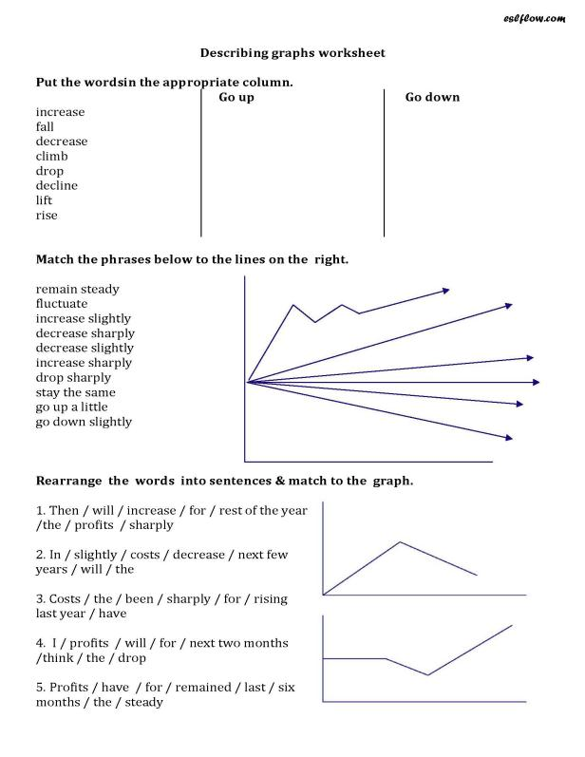

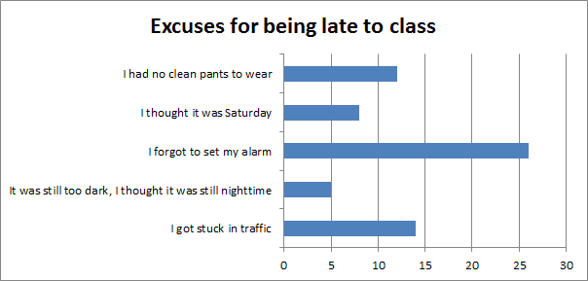

This chart illustrates that forgetting to set their alarms is the excuse given by the large majority of pupils for being late to class. The second considerable proportion , nearly the half , said that when it happened to them to be tardy, it was mainly because of traffic jam. Having no clean pants to wear was another excuse, which eventhough not convincing ,was provided by an undiniably important proportion of about 39%. Another portion of nearly the third said that they sometimes came late because they thought it was Saturday. The funniest excuse among all was provided by the minority who were late because they thought it was still nighttime.
In conclusion, we can see from the chart that pupils give different excuses for being behind time which sometimes seem to be unbelievable and even funny.

